

Care Connect

User Manual

ROLE: Providers and Administrative Assistants

Table of Contents

**Workflow__ Page 2**

**Logging In & Account Reset Page 3**

***Care Connect Application Terms***

***PATIENT PROFILE –*** *Used to receive proper referrals from the SchedulR application.*

***ASSESSMENT -*** *A crisis behavioral assessment completed by a DEC Assessor.*

***NOTES –*** *Additional information, which may be useful for scheduling an appointment, or for a newly scheduled patient.*

***DASHBOARD -*** *Displays a quick summary of complete and incomplete work at your logged in site.*

***[?] TOOL TIP -*** *An icon that provides additional information about a field or button.*

**Editing Personal Account Information Page 7**

**Dashboard Orientation Page 8**

**Editing Provider Profile Information Page 9**

**SchedulR Calendar­ Page 10**

**Appointments Page 11**

**Assessments________­_______ Page 16**

**FAQ/Support Page 18**

Workflow

Logging In & Account Reset

**Logging In**

You will receive an email from [onlinecare@bhpnet.com](mailto:onlinecare@bhpnet.com) that will include a link to log into Care Connect application. Select this link and follow the instructions. Be sure to complete all of the fields marked with a red asterisk.

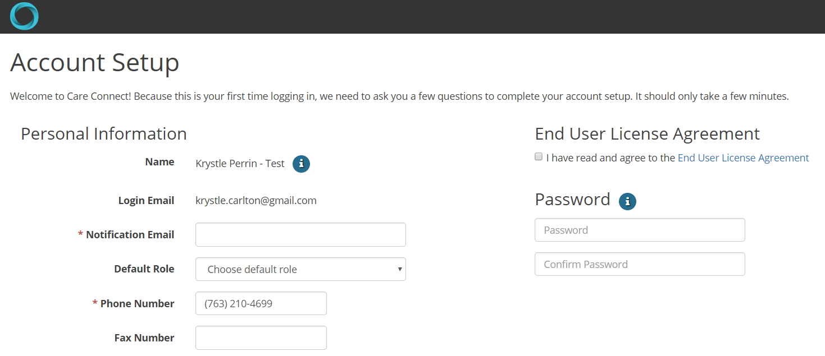

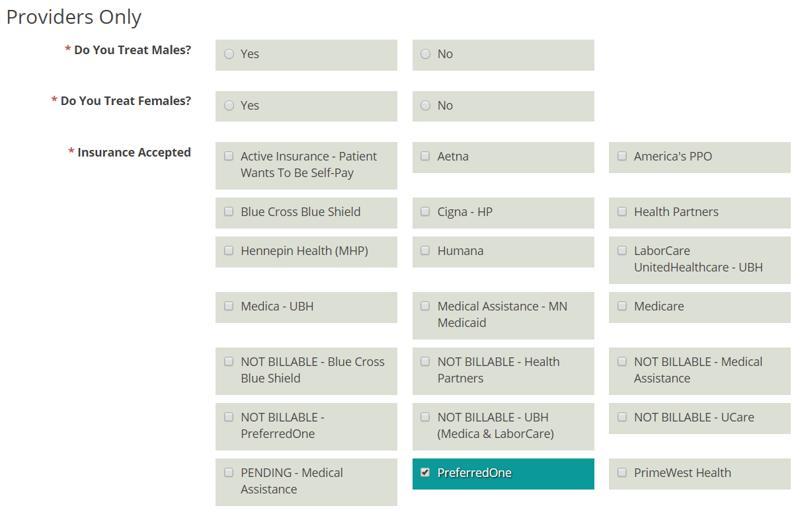

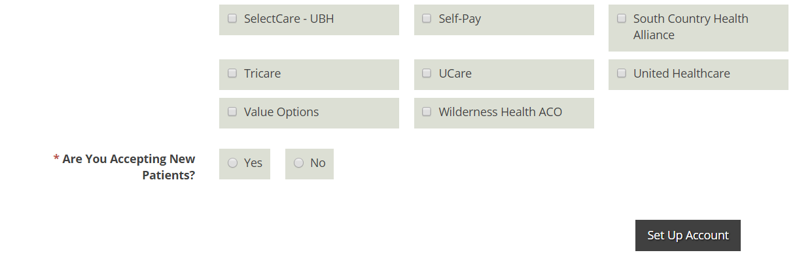

Once you have completed all the fields, click on **Set Up Account**. You will be redirected to the main login page. Please login and see the instructions on page 8 on how to complete your provider profile.

*** In order to appear in provider searches for patient referrals, you must complete both the insurance carriers that you accept AND your specialties of practice. ***

If you did not receive an email, please check your spam or junk mail folders to ensure it was not blocked.

**Account Reset**

If you cannot locate the account activation email, select the “Forgot Password / Reset Account” link on the login page: <https://onlinecare.bhpnet.com>. This link may be used anytime you have locked your account or forgotten your password.

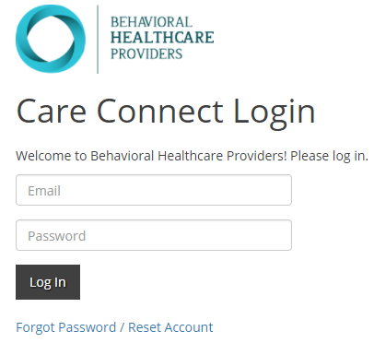

If you continue to experience login issues, please contact us as [webapps@bhpnet.com](mailto:webapps@bhpnet.com).

**Logging Out**

Care Connect will automatically log you out after 15 minutes of inactivity. You may also choose to logout at any time by selecting the logout option in the drop-down menu under your name, role and logged in location.

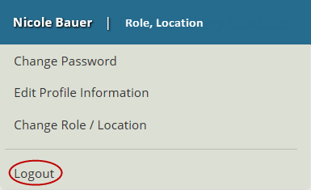

Viewing/Editing Your Personal Account Settings

**Changing Your Password**

You may change your account password at any time by selecting the link for “Change Password” located in the drop-down menu under your name, role and logged in location. You will be directed to the “Reset Password” page at <http://decuat.bhpcare.com/Login/PasswordReset>.

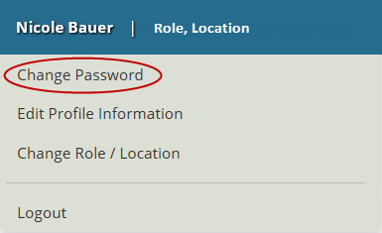

**Editing Your Profile**

You may edit your profile information at any time by selecting the link for “Edit Profile Information” located in the drop-down menu under your name, role and logged in location.

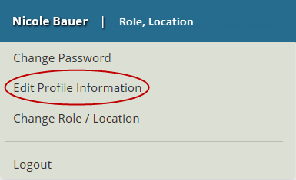

A new window will appear that provides options to update your profile information. You may select the ‘x’ in the top right corner to close the window and cancel any changes made, or select “Save & Close” when your edits are done to save any changes made.

**Can I Login As a Different User?**

No user is allowed to login using someone else’s login information. In extension, no staff member will be able to update passwords for another staff member. Both providers and administrative staff members will be responsible for maintaining their own account.

However, an administrative staff member will continue to be able to edit profiles and appointments for their associated providers. Therefore, a provider is not required to login to their account at any point in time if it is agreed that the administrative staff members will manage their profiles and schedule. A provider must be set up in the system, but may not necessarily need to login on their own.

You may reference “Editing Provider Profile Information” and “Appointments” in the table of contents page for more information about how to complete these tasks.

Dashboard Orientation

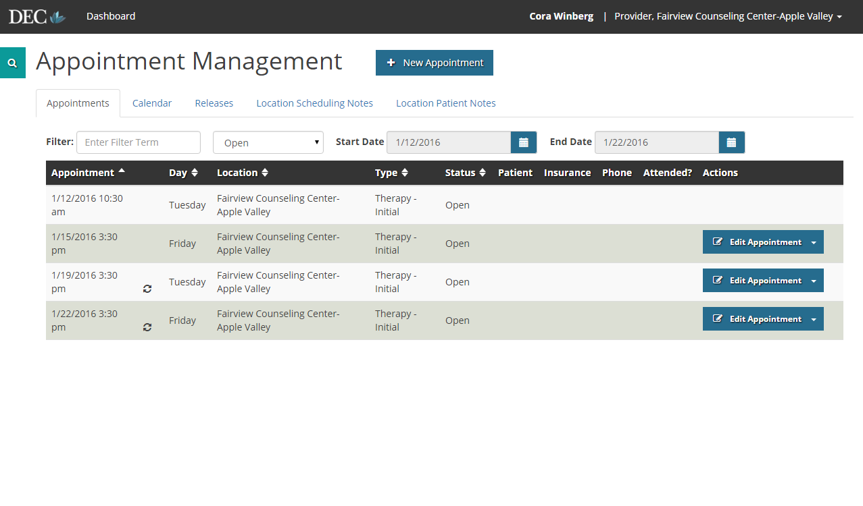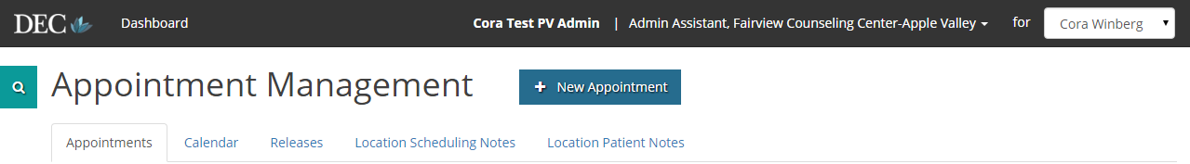

Change Provider

List of appointments for provider

Click to add a new appointment to schedule

Drop-down to view Filled, Open, or Incomplete appointments

Click to edit profile and account settings

Perform a “Patient Search” by clicking this icon

Click to get back to main Dashboard

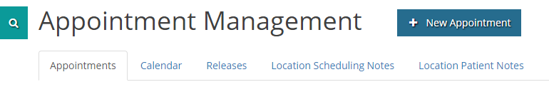

Click to view scheduled appointments

Click to view calendar with appointments

Click to view patient releases

Click to view and edit Scheduling Notes

Click to view and edit Patient Notes

How to Edit a Provider’s Profile Information

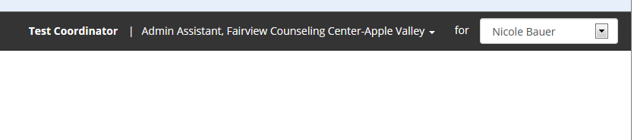

Choose the Provider at the top of your dashboard

*Note: administrative staff members will have access to all providers at their company, while the provider themselves will only have access to their own information.

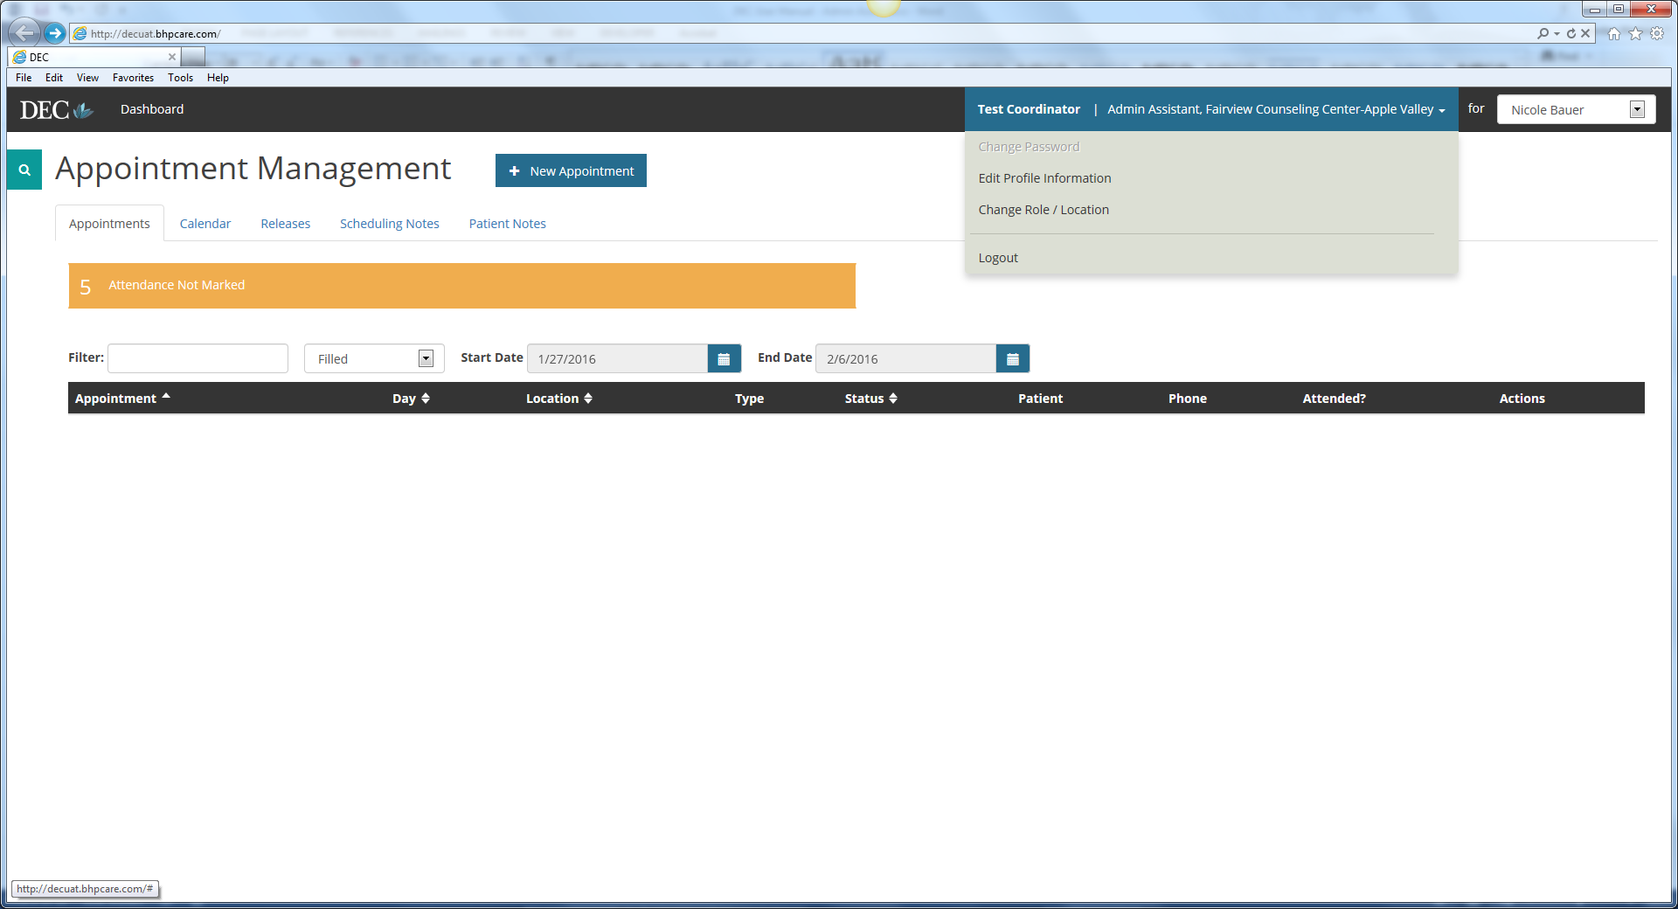

Click “Edit Profile Information” under this drop down

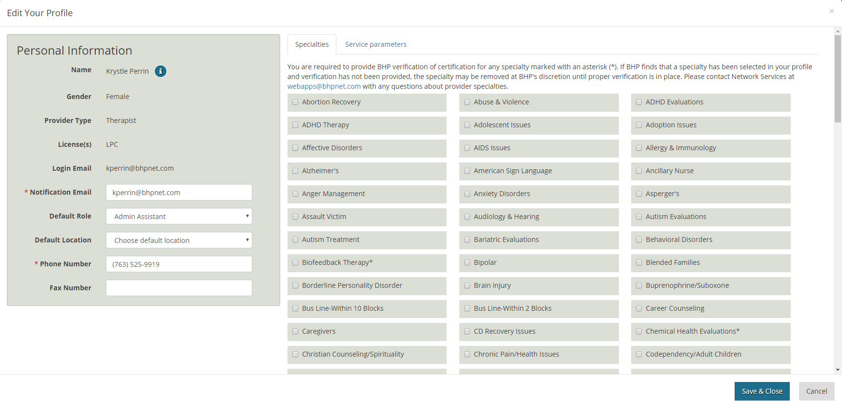

Each one of these tabs must be completed at set up, and updated as needed.

NOTE: Provider appointments will not be filled until the “Service Parameters” are completed and Specialties are added. This ensures clinically appropriate referrals are made.

SchedulR Calendar

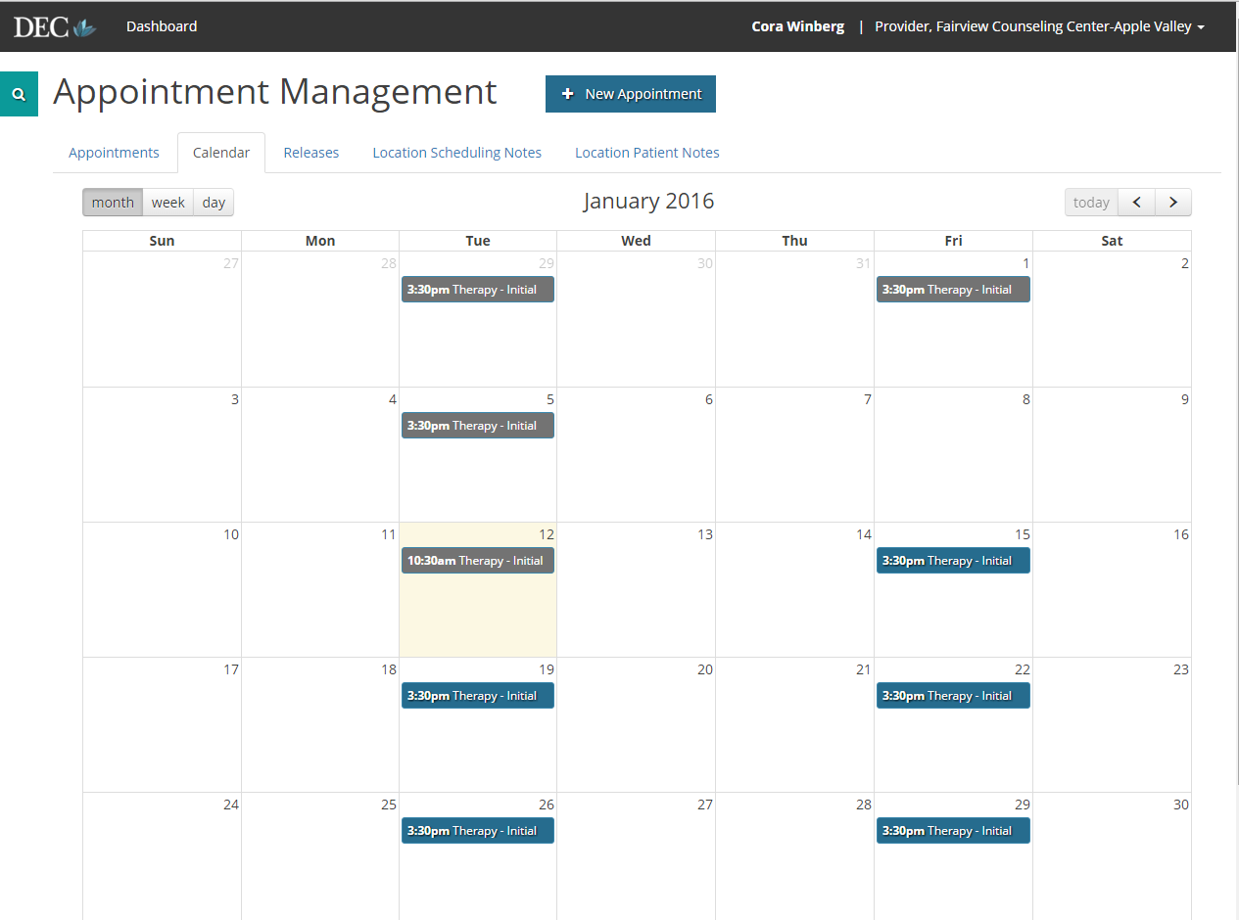

Select desired calendar view

Click to add a new appointment to schedule

Click to change which provider is being viewed

Grey box = old appointment

Blue = current or future appointment

Yellow box = current day

Toggle month/day/week. Click “today” to direct calendar to present day

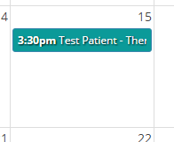

Green/Teal = Scheduled Appointment

Appointments

**Who Can I add an Appointment for?**

Providers will be able to add/access appointments for themselves only. Administrative staff members will have access to all providers at their company. A user can be allowed to have dual roles on one account if needed; it is possible for a user to be set up as both a provider and an administrative staff member.

**Creating an Appointment**

Before adding the first appointment, check to make sure the profile information has been completed. You may add a new appointment at any time by clicking the “+ New Appointment” icon at the top of all pages. Once “+ New Appointment” is selected, a new window will appear with the following options:

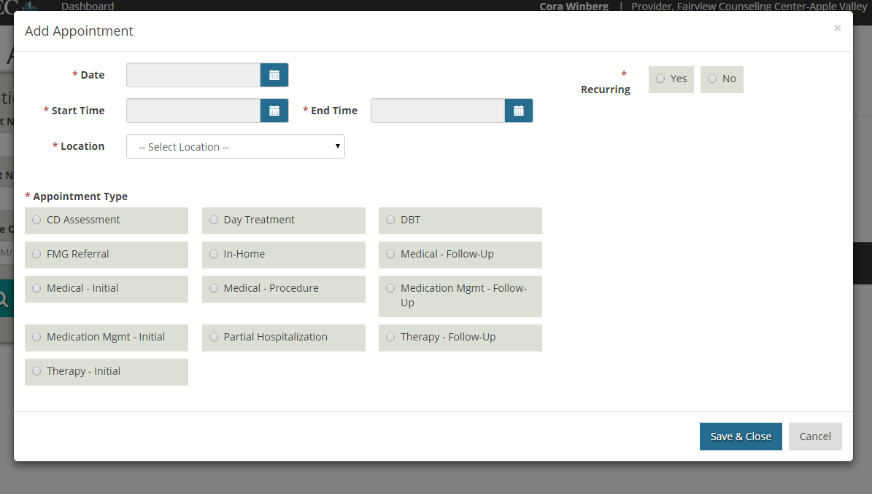

Be sure to fill in all required options, labeled with a “*” symbol. Select the date you wish you add an appointment, followed by the appointment’s start and end time. If your clinic has more than one location, be sure to choose the correct location in which you wish to offer this appointment. Next, select the correct type of appointment to receive proper referrals. Lastly, if you wish to make this appointment occur on a regular basis, select “Yes” in the top right corner by “Reoccurring.” If this appointment is only meant to be offered once, select “No.”

**Editing an Appointment**

You may change appointment attributes at any time by clicking on an appointment on the provider’s calendar and then choosing the “Edit” option.

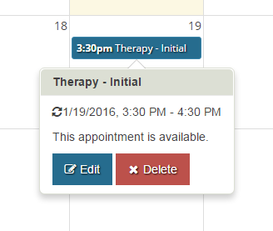

You may also edit an appointment from the “Appointments” page. Be sure to filter for “Open” appointments. Locate the appointment you wish to edit and select “Edit Appointment.”

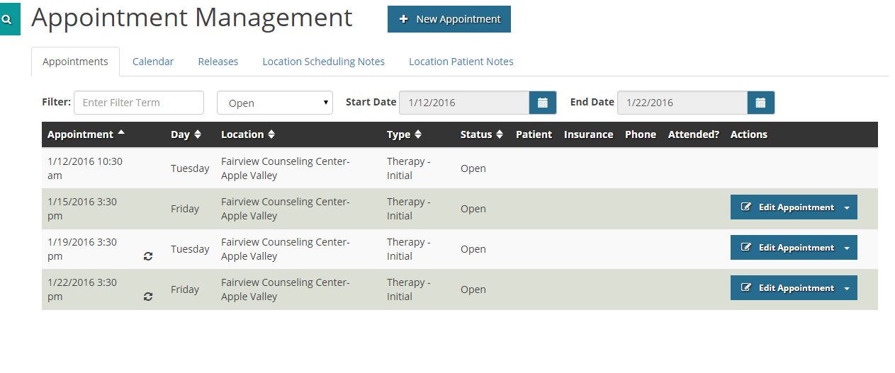

** If the appointment being edited is reoccurring, you will be asked if you wish to edit “Just This One” or if you wish to edit “The Entire Series” of appointments. Choose the correct option and proceed to make the proper changes.

**Viewing an Open Appointment**

You may edit open appointment by selecting the “Appointments” page and filtering for “Open” appointments using the dropdown menu. 

**Viewing a Scheduled Appointment**

You may view all scheduled appointments by going to the “Appointments” page and filtering for “Filled” appointment using the dropdown menu. After the filled appointment(s) appear on the screen, you may view a brief summary of the appointment. This includes scheduled time, day, location (if more than one clinic location), type of appointment, status (Filled, Open, or Incomplete), patient name, patient’s insurance, patient’s phone. The “View Notes” option will display this information in more in-depth detail.

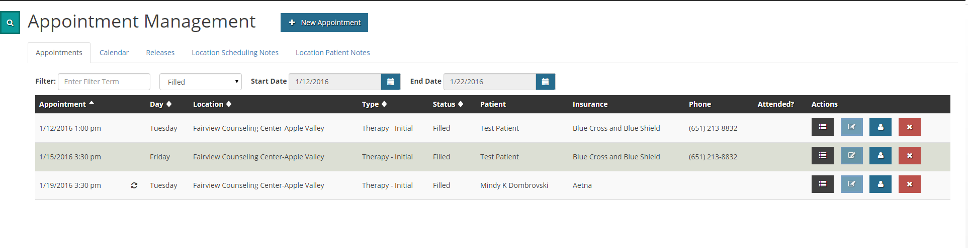

View appointment notes

Filter for “Filled” appointments to see scheduled apts.

View Patient profile

Delete appointment

**View Notes Section**

By clicking the “View Notes” section, a pop-up box will show up with brief appointment notes. If the patient was scheduled by the Intake Department, any pertinent patient information, such as reason for referral and current medications, will show up in the “Other Information” section.

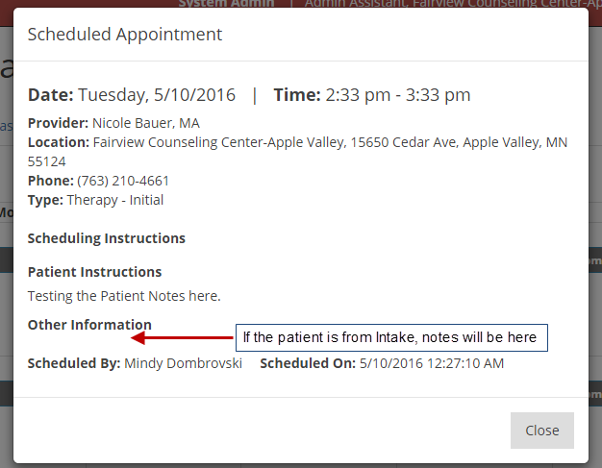

**View Profile Section**

By clicking the “View Profile” section, a pop-up box will show up with detailed patient notes, such as name, DOB, legal guardian (if applicable), and insurance information. If the patient was scheduled from the DEC and signed an ROI, an assessment will be available in the “Assessment” tab.

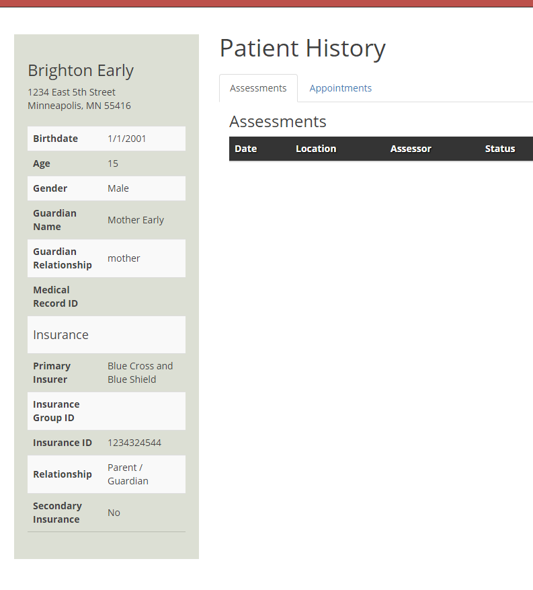

**Marking Attendance**

After a scheduled appointment has passed, your dashboard will show that you have “Attendance Not Marked”

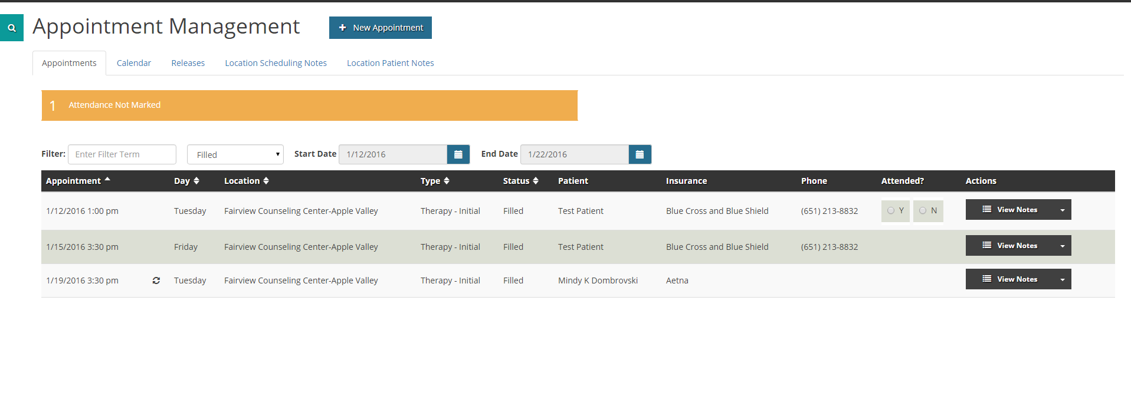

When this notification is displayed, you must check “Yes” or “No” under the “Attended” column to report if the patient attended the scheduled appointment, or if they did not attend the appointment.

Assessments

**Viewing an Assessment**

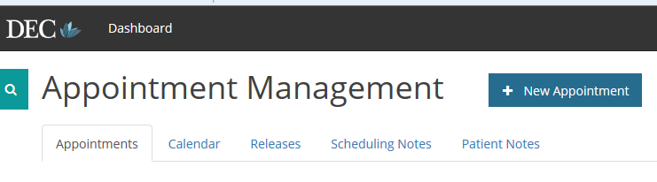

Click “Releases”. Make sure that you are on the correct provider’s page before you do this

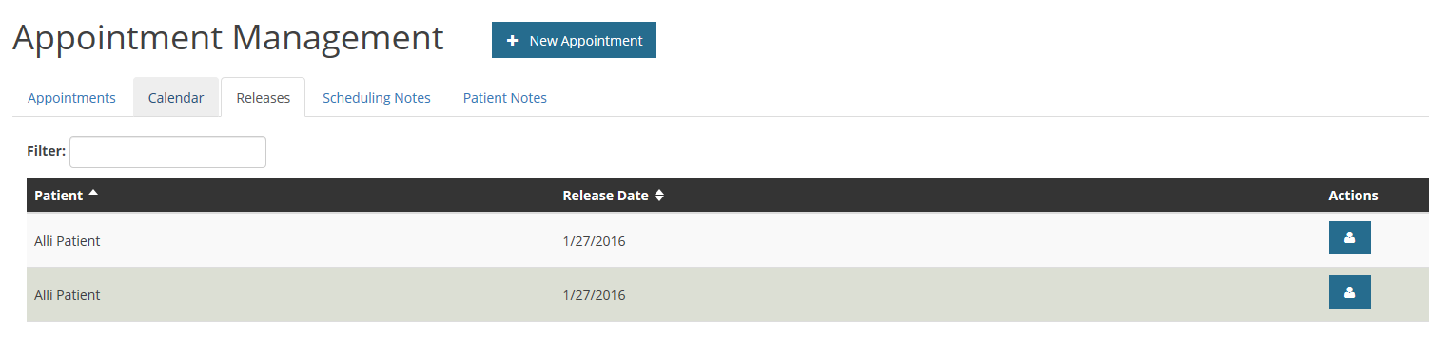

Click on “View Profile” for the assessment you would like to view

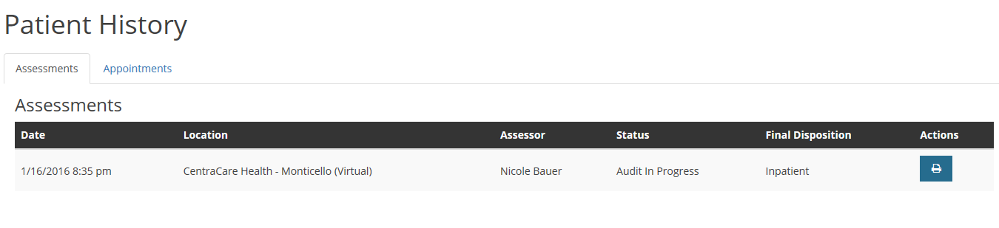

Click “View Report”

**Printing an Assessment**

For the first step, open the assessment. You may reference the steps above if needed

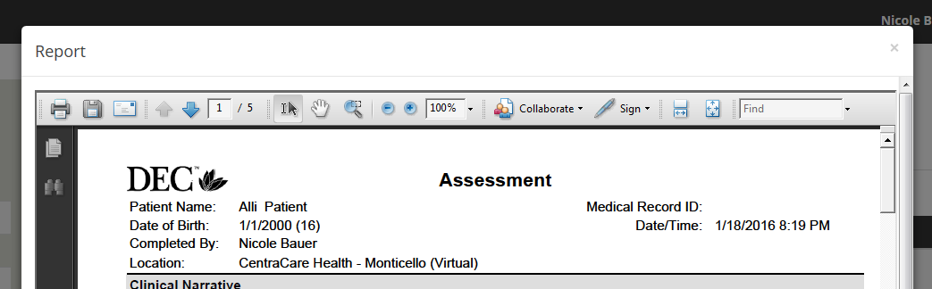

Click “Print”

Frequently Asked Questions

**Who do I contact with technical issues or questions?**

For any SchedulR-related questions, please email [webapps@bhpnet.com](mailto:webapps@bhpnet.com).

**Who do I contact with appointment questions?**

For any SchedulR-related questions, please email [webapps@bhpnet.com](mailto:webapps@bhpnet.com).